Online Train Reservation System
1. AIM
To design and develop an Online Train Reservation System using HTML, CSS, and JavaScript that allows passengers to log in, search for trains, check seat availability, enter passenger details, book tickets, check PNR status, cancel tickets, and calculate refunds. The system also provides an admin panel to manage train details, fares, and reservations.
2. PROCEDURE
- Open Visual Studio Code.
- Create a folder named TrainReservation.
- Create a file named index.html inside the folder.
- Write the HTML code to design the train reservation webpage.
- Use CSS to style the webpage and make it responsive.
- Use JavaScript to implement train searching, seat availability, passenger login, ticket booking, PNR generation, cancellation, and refund calculation.
- Save the file using Ctrl + S.
- Open index.html in a web browser.
- Enter the passenger login details and search for trains by origin, destination, and journey date.
- Select a train, enter passenger details, choose the ticket class, and select a payment mode.
- Book a ticket and verify the generated PNR number.
- Check the PNR status and test ticket cancellation and refund calculation.
- Open the admin panel to add train details and view reservations.
3. HTML CODE
Save the following complete code as index.html.

<!DOCTYPE html>
<html lang="en">
<head>
<meta charset="UTF-8">
<meta name="viewport" content="width=device-width, initial-scale=1.0">
<title>Train Reservation System</title>

<style>
body {
font-family: Arial, sans-serif;
margin: 0;
background: #eef2f7;
color: #222;
}
header {
background: #12376a;
color: white;
padding: 20px;
text-align: center;
}
nav {
background: #09254b;
padding: 12px;
text-align: center;
}
nav a {
color: white;
text-decoration: none;
margin: 10px;
display: inline-block;
}
.container {
max-width: 950px;
margin: auto;
padding: 15px;
}
section {
background: white;
margin: 18px 0;
padding: 20px;
border-radius: 8px;
box-shadow: 0 2px 6px #ccd2dc;
}
h2 {
color: #12376a;
}
label {
display: block;
font-weight: bold;
margin-top: 10px;
}
input, select {
width: 100%;
padding: 10px;
margin-top: 5px;
border: 1px solid #bbb;
border-radius: 4px;
}
button {
background: #1769aa;
color: white;
padding: 10px 15px;
border: none;
border-radius: 4px;
margin-top: 12px;
cursor: pointer;
}
button:hover {
background: #0b4778;
}
.train {
border: 1px solid #ddd;
padding: 12px;
margin-top: 10px;
border-radius: 5px;
}
.output {
background: #e6f3ff;
padding: 12px;
margin-top: 12px;
overflow-wrap: anywhere;
}
footer {
text-align: center;
background: #12376a;
color: white;
padding: 15px;
}
@media(max-width:600px) {
nav a {
margin: 5px;
}
section {
padding: 14px;
}
}
</style>
</head>

<body>

<header>
<h1>Online Train Reservation System</h1>
<p>Search Trains | Book Tickets | Check PNR</p>
</header>

<nav>
<a href="#login">Login</a>
<a href="#search">Search Trains</a>
<a href="#booking">Booking</a>
<a href="#pnr">PNR Status</a>
<a href="#cancel">Cancellation</a>
<a href="#admin">Admin</a>
</nav>

<div class="container">

<section id="login">
<h2>Passenger Login / Registration</h2>

<label>Username</label>
<input id="username" placeholder="Enter username">

<label>Password</label>
<input id="password" type="password" placeholder="Enter password">

<button onclick="login()">Login</button>
<button onclick="register()">Register</button>
<p id="loginResult"></p>
</section>

<section id="search">
<h2>Search Trains</h2>

<label>Origin Station</label>
<input id="source" placeholder="Chennai">

<label>Destination Station</label>
<input id="destination" placeholder="Bengaluru">

<label>Journey Date</label>
<input type="date" id="date">

<label>Class</label>
<select id="classType">
<option>Sleeper</option>
<option>AC 3 Tier</option>
<option>AC 2 Tier</option>
<option>Chair Car</option>
</select>

<button onclick="searchTrains()">Search Trains</button>
<div id="trainResults"></div>
</section>

<section id="booking">
<h2>Passenger Details and Ticket Booking</h2>

<p id="selectedTrain">No train selected.</p>

<label>Passenger Name</label>
<input id="passenger" placeholder="Full name">

<label>Passenger Age</label>
<input id="age" type="number" min="1" max="120">

<label>Gender</label>
<select id="gender">
<option>Male</option>
<option>Female</option>
<option>Other</option>
</select>

<label>Number of Tickets</label>
<input id="count" type="number" min="1" max="6" value="1">

<label>Payment Mode</label>
<select id="payment">
<option>Online (Demo)</option>
<option>Offline (Demo)</option>
</select>

<p id="fare">Select a train to see the fare.</p>

<button onclick="bookTicket()">Book Ticket</button>
<div id="bookingResult" class="output"></div>
</section>

<section id="pnr">
<h2>PNR Status</h2>
<label>Enter PNR Number</label>
<input id="pnrInput" placeholder="Enter PNR">
<button onclick="checkPNR()">Check Status</button>
<div id="pnrResult" class="output"></div>
</section>

<section id="cancel">
<h2>Ticket Cancellation and Refund</h2>
<label>Enter PNR Number</label>
<input id="cancelPNR" placeholder="Enter PNR">
<button onclick="cancelTicket()">Cancel Ticket</button>
<div id="cancelResult" class="output"></div>
</section>

<section id="admin">
<h2>Admin Panel (Demo)</h2>

<label>Admin Username</label>
<input id="adminUser" placeholder="admin">

<label>Admin Password</label>
<input id="adminPass" type="password" placeholder="admin123">

<button onclick="adminLogin()">Admin Login</button>

<div id="adminPanel" hidden>
<h3>Add Train</h3>

<label>Train Number</label>
<input id="newNumber">

<label>Train Name</label>
<input id="newName">

<label>Origin</label>
<input id="newSource">

<label>Destination</label>
<input id="newDestination">

<label>Fare per Passenger (₹)</label>
<input id="newFare" type="number" min="1">

<label>Available Seats</label>
<input id="newSeats" type="number" min="0">

<button onclick="addTrain()">Add Train</button>
<button onclick="viewBookings()">View Bookings</button>

<div id="adminResult" class="output"></div>
</div>
</section>

</div>

<footer>
<p>Online Train Reservation System - Mini Project</p>
</footer>

<script>
let user = "";
let selected = null;
let nextPNR = 100000001;

let trains = [
{
number: "12601",
name: "Chennai Express",
source: "Chennai",
destination: "Bengaluru",
fare: 450,
seats: 40
},
{
number: "12603",
name: "Superfast Express",
source: "Chennai",
destination: "Hyderabad",
fare: 650,
seats: 30
},
{
number: "12605",
name: "Intercity Express",
source: "Bengaluru",
destination: "Chennai",
fare: 350,
seats: 25
}
];

let bookings = [];

function login() {
let u = document.getElementById("username").value.trim();
let p = document.getElementById("password").value;

if (!u || !p) {
alert("Enter username and password.");
return;
}

user = u;
document.getElementById("loginResult").textContent =
"Demo login successful. Welcome " + user;
}

function register() {
let u = document.getElementById("username").value.trim();
let p = document.getElementById("password").value;

if (!u || !p) {
alert("Enter username and password.");
return;
}

document.getElementById("loginResult").textContent =
"Demo registration completed. You can now log in.";
}

function searchTrains() {
let s = document.getElementById("source").value.trim();
let d = document.getElementById("destination").value.trim();
let date = document.getElementById("date").value;
let result = document.getElementById("trainResults");

result.replaceChildren();

if (!s || !d || !date) {
alert("Enter origin, destination and journey date.");
return;
}

if (s.toLowerCase() === d.toLowerCase()) {
alert("Origin and destination must be different.");
return;
}

let found = trains.filter(t =>
t.source.toLowerCase() === s.toLowerCase() &&
t.destination.toLowerCase() === d.toLowerCase()
);

if (found.length === 0) {
result.textContent = "No trains found for this demo route.";
return;
}

found.forEach(t => {
let div = document.createElement("div");
div.className = "train";

let details = document.createElement("p");
details.textContent =
t.number + " - " + t.name +
" | " + t.source + " to " + t.destination +
" | Date: " + date +
" | Seats: " + t.seats +
" | Fare: ₹" + t.fare;

let button = document.createElement("button");
button.textContent = "Select Train";
button.onclick = () => {
selected = t;
document.getElementById("selectedTrain").textContent =
t.name + " selected. Class: " +
document.getElementById("classType").value;
updateFare();
};

div.append(details, button);
result.appendChild(div);
});
}

function updateFare() {
if (!selected) return;

let count = Number(document.getElementById("count").value);

document.getElementById("fare").textContent =
"Total Fare: ₹" + (selected.fare * count);
}

document.getElementById("count").addEventListener("input", updateFare);

function bookTicket() {
if (!user) {
alert("Please log in first.");
return;
}

if (!selected) {
alert("Search and select a train first.");
return;
}

let name = document.getElementById("passenger").value.trim();
let age = Number(document.getElementById("age").value);
let count = Number(document.getElementById("count").value);
let date = document.getElementById("date").value;

if (!name || !Number.isInteger(age) || age < 1 || age > 120 ||
!Number.isInteger(count) || count < 1 || count > 6 || !date) {
alert("Enter valid passenger details.");
return;
}

if (selected.seats < count) {
alert("Insufficient seats available.");
return;
}

selected.seats -= count;

let pnr = String(nextPNR++);

let booking = {
pnr: pnr,
user: user,
name: name,
train: selected.name,
number: selected.number,
date: date,
count: count,
fare: selected.fare * count,
payment: document.getElementById("payment").value,
classType: document.getElementById("classType").value,
status: "Confirmed",
refund: 0
};

bookings.push(booking);

document.getElementById("bookingResult").textContent =
"Ticket booked in demo! PNR: " + pnr +
" | Passenger: " + name +
" | Train: " + selected.name +
" | Date: " + date +
" | Class: " + booking.classType +
" | Tickets: " + count +
" | Fare: ₹" + booking.fare +
" | Payment: " + booking.payment +
". No actual payment was processed.";

document.getElementById("pnrInput").value = pnr;
document.getElementById("cancelPNR").value = pnr;

updateFare();
}

function checkPNR() {
let pnr = document.getElementById("pnrInput").value.trim();
let b = bookings.find(x => x.pnr === pnr);

document.getElementById("pnrResult").textContent = b
? "PNR: " + b.pnr +
" | Train: " + b.train +
" | Date: " + b.date +
" | Status: " + b.status
: "PNR not found in this demo session.";
}

function cancelTicket() {
let pnr = document.getElementById("cancelPNR").value.trim();
let b = bookings.find(x => x.pnr === pnr);

if (!b) {
document.getElementById("cancelResult").textContent =
"Booking not found.";
return;
}

if (b.status === "Cancelled") {
document.getElementById("cancelResult").textContent =
"Ticket already cancelled.";
return;
}

// Example refund rule: 80%. Not an official railway rule.
b.refund = Math.round(b.fare * 0.8);
b.status = "Cancelled";

let train = trains.find(t => t.number === b.number);
if (train) train.seats += b.count;

document.getElementById("cancelResult").textContent =
"Ticket cancelled. PNR: " + b.pnr +
" | Refund calculated: ₹" + b.refund +
". No actual refund was issued.";
}

function adminLogin() {
let u = document.getElementById("adminUser").value;
let p = document.getElementById("adminPass").value;

if (u === "admin" && p === "admin123") {
document.getElementById("adminPanel").hidden = false;
document.getElementById("adminResult").textContent =
"Demo admin login successful.";
} else {
alert("Invalid demo admin credentials.");
}
}

function addTrain() {
let number = document.getElementById("newNumber").value.trim();
let name = document.getElementById("newName").value.trim();
let source = document.getElementById("newSource").value.trim();
let destination = document.getElementById("newDestination").value.trim();
let fare = Number(document.getElementById("newFare").value);
let seats = Number(document.getElementById("newSeats").value);

if (!number || !name || !source || !destination ||
source.toLowerCase() === destination.toLowerCase() ||
!Number.isFinite(fare) || fare <= 0 ||
!Number.isInteger(seats) || seats < 0 ||
trains.some(t => t.number === number)) {
alert("Enter valid details and a unique train number.");
return;
}

trains.push({
number: number,
name: name,
source: source,
destination: destination,
fare: fare,
seats: seats
});

document.getElementById("adminResult").textContent =
"Train added successfully to the current demo session.";
}

function viewBookings() {
let result = document.getElementById("adminResult");
result.replaceChildren();

if (bookings.length === 0) {
result.textContent = "No bookings found.";
return;
}

bookings.forEach(b => {
let p = document.createElement("p");
p.textContent =
"PNR: " + b.pnr + " | " + b.name +
" | " + b.train + " | Fare: ₹" + b.fare +
" | " + b.status;
result.appendChild(p);
});
}
</script>

</body>
</html>
Output:
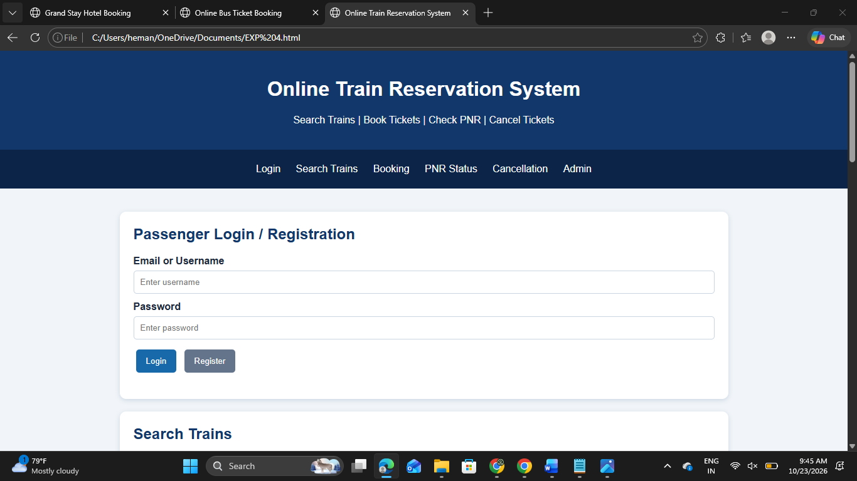
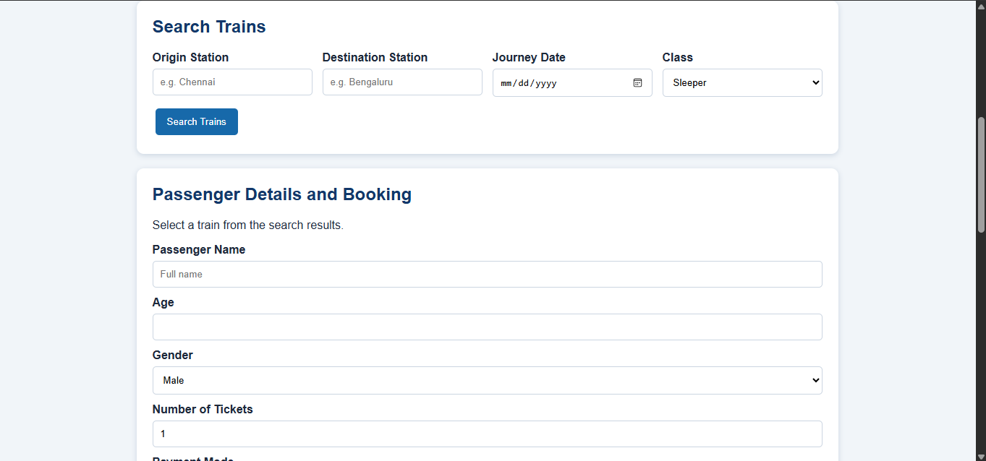
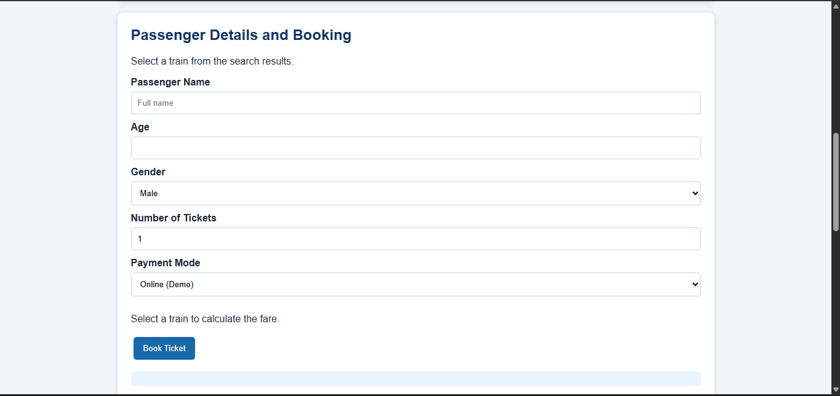
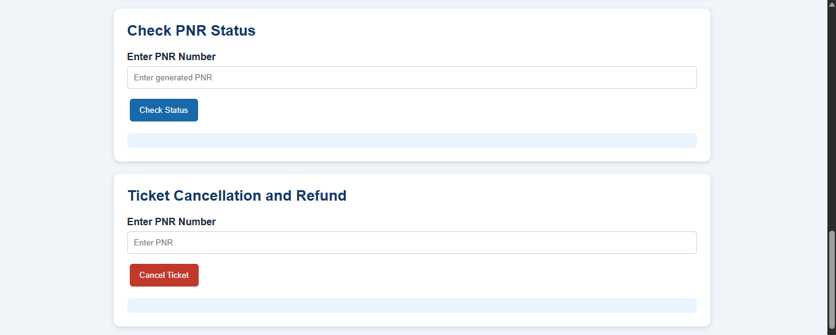
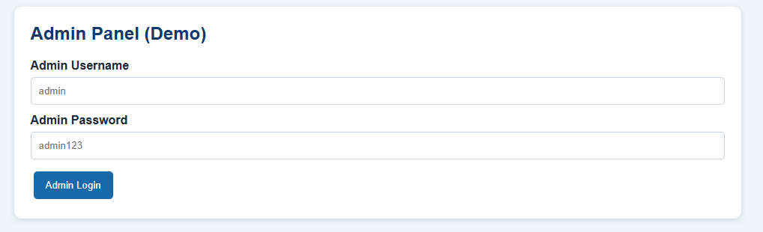
4. RESULT
The Online Train Reservation System was designed and executed successfully using HTML, CSS, and JavaScript. The webpage demonstrates passenger login and registration, train searching, seat availability, passenger details, fare calculation, ticket booking, PNR generation and status checking, ticket cancellation, refund calculation, and admin train management. The webpage is responsive and can be viewed on desktop and mobile devices.

